**Programming II**

**Fall 2021**

**Handong Global University**

**School of Entrepreneurship and ICT**

**Project plan**

**Team Members**

|  |  |
| --- | --- |
| Name | Student ID |
| Seungyoo Lee | 21300543 |
| Joowon Kim | 21300178 |
| Suhui Jung | 21900666 |
|  |  |

# App description

*Our program is personal budgeting program. This program makes it easy for users to manage and plan personal budgeting .*

# Features

*The biggest feature of our program is that the large categories of Planning, Expense Input, and Monitoring work together to help users manage their budgets efficiently.*

*The Planning section will allow users to make monthly consumption plans by selecting the categories that existed or adding new categories that users want. Our team will use an array to make data and record by category and date.*

*In the Expense input section, users can enter expenditures according to the date and category, and record explanations related to them. In addition, the total amount of expenditure is displayed monthly, yearly, or daily, so users can check the total expenditure according to the wanted period of time. This will also add up all costs using the array and for-loop.*

*In the Monitoring section, users can compare the plan with the actual amount of consumption according to the wanted period. This comparison can not only be compared with the total amount but can also be compared by category. Moreover, users can edit these expenses. In this section, we compare the array in the planning section and the array in the expense section when the user selects a category or period. It will be calculated as a planning expense according to the selected option. if this result is a negative value (planning<expense), we print it out more outstandingly.*

*To introduce a little more additional feature, we think to express visually (graphs, bar charts) is more efficient, so we plan to provide charts to users through UI.*

# *User interface*

*We will use UI components such as graphs, icons, and statistical data representing personal budjet.*

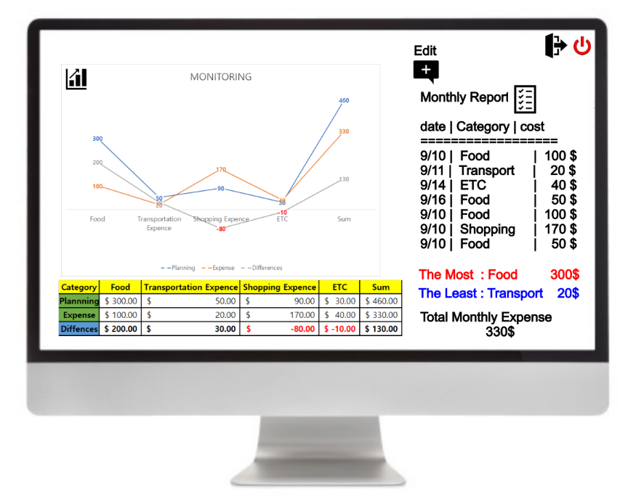

# Resources

*icon : https: hotpot.ai/free-icons*

*images and graphics :* [*www.pixabay.com*](http://www.pixabay.com)

*\*this can be changable.*

# Work allocation

Our team members will collaborate with each other and work together to make up for the shortcomings.

-Seungyoo Lee(21300543):

<project director>

While working as a project director, he will be in charge of code engine and overall project management.

-Joowon Kim(21300178):

<data manager>

He is going to do database work and major debugging.

-Suhui Jung(21900666):

<UI manager>

She will play a role in applying UI suitable for the situation to the app and managing the working environment and work schedule.

*We will handle our program and each others documents

*.*

# Schedule

*Divide your project into five milestones. These are your own internal milestones and these should correspond to the features and characteristics of your program. You should use these milestones in your project management. Describe each milestone and set a deadline.*

|  |  |  |
| --- | --- | --- |
| **Milestone** | **Description** | **Deadline** |
| **1**  **choose topic,project plan** | Set topics and install a version control system(Github,Git with SourceTree) and project management(Slack) to efficiently perform team activities. In addition, we plan overall activities to execute the project plan in order. | Week 4 |
| **2**  **UI design** | Design the visual UI of the project using various icons and graphic tools that fit our topic. | Week 6 |
| **3**  **First app draft** | Collect databases, code and design to analyze them, and then implement the first app. | Week 10 |
| **4**  **Final app,**  **Final report** | while repeating the process of execution-evaluation-modification complete the final app with the best results and write a report . | Week 15 |
| **5**  **Presentation** | Prepare a presentation that can explain the functions and contents of our app well. (Team members will divide the roles) | Week 16 |